

FURTHER EDUCATION AND TRAINING CERTIFICATE: INFORMATION TECHNOLOGY: SYSTEMS DEVELOPMENT
ID 78965 LEVEL 4 – CREDITS 165
FACILITATOR GUIDE
SAQA: 14944
EXPLAIN HOW DATA IS STORED ON COMPUTERS

Facilitator Information:

Details | Please Complete this Section
Name & Surname:
Organisation:
Unit/Dept:
Facilitator Name:
Date Started:
Date of Completion:

Copyright
All rights reserved. The copyright of this document, its previous editions and any annexures thereto, is protected and expressly reserved. No part of this document may be reproduced, stored in a retrievable system, or transmitted, in any form or by any means, electronic, mechanical, photocopying, recording or otherwise without the prior permission.
Facilitator Guide Introduction
About the Facilitator Guide… | This Facilitator Guide provides a comprehensive overview of EXPLAIN HOW DATA IS STORED ON COMPUTERS, and forms part of a series of Facilitator Guides that have been developed for S. The series of Facilitator Guides are conceptualized in modular’s format, in accordance with the Learner Guides. This guide has been designed and developed to assist you in effectively and efficiently prepare and implement your various training interventions.
Purpose | The purpose of this Facilitator Guide is to assist facilitators in delivering training sessions, related to  The Guide also provides information on facilitation methodologies and strategies to be adopted during training sessions.
US No | US Title |  | Level | Credit
14944 | Explain how data is stored on computers |  | 5 | 6
Objectives | - Explain how data is stored on computers
Outcomes | The qualifying learner is capable of:  - Explain how data is stored on computers
Facilitation Methodology | The programme is very practical and aims to provide practical tools and skills for adult learners. The methodology should ensure that:  - The learning environment is physically and psychologically comfortable.  - Contact training periods are short and varied to avoid boredom.  - Learner expectations are articulated and clarified and managed by the learner and facilitator.  - The experience of participants is acknowledged and drawn on in the learning programme.  - Facilitation, rather than teaching, is used to allow participants to participate fully.  - The facilitator balances the presentation of new material, debate and discussion in such a way that the outcomes of the module are met, while ensuring that all participants are valued and are able to contribute to the learning process.  - The learning will be problem-oriented, personalized and accepting of participants’ needs for self-direction and personal responsibility.  - The module presented in a way that allows a participant to participate fully in the language of their choice.  - The facilitation process accommodates participants who may not be literate, or who are not literate in English.  The contact session uses a participatory methodology. This is appropriate for adult audiences who come with a wide range of experiences and skills. It also accommodates a broader range of learning styles. Some techniques that can be used include:
  Method | Description
  Structured learning experience | Participants engage with a complex game or activities that represent real-life situations that they may encounter in the course of their work as a Ward Committee member.
  Case study | This is a realistic story or real-life situation that has taken place, in which participants need to apply their knowledge and skills to practice how they can deal with the issues presented.
  Group work | Participants work on tasks in their groups and report their findings back to plenary.
  Lecture | The facilitator presents a short talk (maximum of 10 minutes) to introduce a new subject, to provide details, or to wrap up a session.
  Discussion | This is a free exchange of ideas or experiences on a particular topic. It may be between the facilitator and the participants or between the participants.
  Brainstorming | Participants generate a number of ideas on a particular subject or question. It may be used to gather different opinions or to find out what participants know about a particular topic.
  Role-play | Participants are asked to act out a scenario where each participant plays a particular role. A role-play may be used to illustrate how people respond in different situations.
  Panel discussion | This is a planned presentation by one or more experts. It may be followed by a discussion session or a round of questions.
Resources | - White board and/or Flipcharts  - Laptop & Data Projector (not compulsory)  - Facilitator & Learner Guide  - Learner Workbook  - Appendices (attached to learner guide)
Time | Contact/ Facilitation Days
Time | Theory
Time | Practical
Time | Assessments
Time | Workplace Application Days

Facilitator’s Checklist & Training Aids
Learner support strategies:
Learners are supplied with all resources and aids as required by the program – including:
- Objects & devices such as equipment, protective clothing, and safety gear, etc.
- Learner Guides and Learner Workbook
- Visual aids, etc.

Use this checklist below during your preparation to ensure that you have all the equipment, documents and training aids for a successful session.

Preparation: | Yes | No
Qualification Knowledge – I have familiarised myself with the content of the applicable qualification
Unit Standard Knowledge – I have familiarised myself with the content of all aspects of the applicable unit standard
Content Knowledge – I have sufficient knowledge of the content to enable me to facilitate with ease
Application knowledge – I understand the programme matrix & have prepared for programme delivery accordingly
Contextualisation – I have included information which is specific to the commodity and practices related to the commodity
Ability to respond to learners background & experience – I have studied the learner demographics, age group, experience & circumstances & prepared for programme delivery accordingly
Enthusiasm & Commitment – I am passionate about my subject & have prepared my programme delivery to create a motivating environment with real commitment to success
Enterprise knowledge – I know & understand the values, ethics, vision & mission of the workplace & have prepared my programme delivery, reporting & administrative tasks accordingly.
Equipment check:
Learner guides x 1 per learner
Assessment guides x 1 per learner
Writing materials & stationary (facilitator & learner)
White board & pens
Flip chart paper
Proximal projector & screen
Laptop & programme disk
Sample Hand-outs and examples of laws and other relevant documents
Safety gear as prescribed by unit standard and applicable legislation
Documentation checklist:
Attendance Register
Course Evaluation
Learner Course Evaluation
Portfolios of evidence

Learning Program Time Frames
 | Total time allocated (hours) | Theoretical learning time allocated (hours) | Practical learning time allocated (hours) | Activities to be completed
Complete Program (including summative assessment)
Learner Orientation and “Ice Breaker” | 1 hour | 30 minutes | 30 minutes
Purpose, Introduction and Learner Directions | 1 hour | 30 minutes | 30 minutes
Conduct negotiations to deal with conflict situations | 80 hour | 24 hours | 56 hours
Preparation for Assessment & revision | 0.5 | - | - | -

TRAINING PROGRAM

Briefing Session: Day1

1. Introduction to the Learning Units

 | Start with an “ice-breaker”, and eventually discuss the global outcome of the learning units with learners and emphasize the assessment process.
 | Topics | Time | Remarks
 | - Ice Breaker  - Course expectations  - Assessment Criteria  - Learner’s Responsibilities | 15 min  10 min  5 min | Please refer to Learner Guide and Assessment Guide for details.

2. Training Ground Rules
 | Discuss the training session ground rules with learners to avoid disturbance during the session
 | Topics | Time | Remarks
 | - Learning Units estimated time  - Ethical behavior  - Cellular phones – (off/silent)  - Breaks – (tea, lunch….)  - Etc… | 10 Min | Write down the training session ground rules and keep them posted in the classroom for the duration of the session.

WORKBOOK MEMORANDA

Learning Unit1
Explain how data is stored on computers

UNIT STANDARD NUMBER : 14944
LEVEL ON THE NQF : 4
CREDITS : 7
FIELD : Human and Social Studies
SUB FIELD : People/Human-Centred Development

PURPOSE: | This unit standard is intended:  to provide conceptual knowledge of the areas covered  for those working in, or entering the workplace in the area of Information Systems and Technology Management  as additional knowledge for those wanting to understand the areas covered  People credited with this unit standard are able to:  Describe the roles of IS departments in organisations  Describe the structures of IS departments in organisations  The performance of all elements is to a standard that allows for further learning in this area.
LEARNING ASSUMED TO BE IN PLACE:

SESSION 1.
Demonstrate an understanding of computer data types.
Learning Outcomes
- 1. The demonstration distinguishes between data types and includes examples.
- 2. The description of the use of coding systems in a business environment distinguishes categories of coding systems and includes examples.
- 3. The demonstration illustrates how data manipulation operations are performed on data types.

Activity | Questions Description | Mark
1 | Demonstrate an understanding of computer data types. | 5

A data type is a classification of the type of data that a variable or object can hold in computer programming. Data type is an important factor in virtually all computer programming languages, including visual basic, C#, C++ and JavaScript. When programmers create computer applications, both desktop and web-based, data types must be referenced and used correctly, to ensure the result of the application's functions is correct and error-free.
PRIMITIVE DATA TYPE
- Boolean type
Boolean data type refers to those types of computer data which represent the values in two forms i.e. true and false. All the values are represented as true and false or yes and no. these are also known as logical data. In some software, it has been interpreted in the form of numbers which indicates either its true or false, 0 is considered as false while other digit is referred as true.
- Numeric type
Numeric data is one of the very common types of computer data which simply means numbers. Numbers can be many forms including, integers, real numbers, currency calculation, percentage, binary numbers etc. some software use different language for such numeric type of data which includes, single, double or float.
1. Integers: It is consisting of whole numbers and can be represented in negative as well as positive. It doesn’t have any decimal values.
2. Real numbers: It contains decimal and fractional values as well and can be represented in negative and positive.
3. Currency: It contains a specific symbol which refers to a particular country. This type of numeric value is recorded till two decimal digits.
4. Percentage: Percentage values are recorded in a way that it is calculated out of 100 and can be denoted in a whole number as well as in decimal values. It has a specific percentage symbol (%) which is used to indicate percentage value.
COMPOSITE DATA TYPE
Composite data type is a combination of primitive data type; they combine to form composite data type which is also known as data structure. There are different types of composite data, which serves different purposes like, array, union, record, sets, objects and tagged union.
ALPHANUMERIC DATA TYPE:
Alphanumeric data simply means one of the types of computer data that contains alphabets as well as numbers. It is very common type of data storage system, which allows different type of computer data to store in one place. It contains alphabets, numbers, symbols, space and punctuation marks. It records every bit of details you want to store in your computer. It is also referred as text data.
ABSTRACT DATA TYPE:
Abstract data type is one of the rare types of computer data; it doesn’t have any representation and implementation. It is just a vague term or language used which don’t have any purpose. Array and records contain such types of computer data, they are considered as concrete as they specify the elements present it a memory.

Activity | Questions Description | Mark
2 | Describe the use of coding systems in a business environment distinguishes categories of coding systems and includes examples. | 5

To represent numeric, alphabetic, and special characters in a computer's internal storage and on magnetic media, we must use some sort of coding system. In computers, the code is made up of fixed size groups of binary positions. Each binary position in a group is assigned a specific value; for example 8, 4, 2, or 1. In this way, every character can be represented by a combination of bits that is different from any other combination. In this section you will learn how the selected coding systems are used to represent data. The coding systems included are Extended Binary Coded Decimal Interchange Code (EBCDIC), and American Standard Code for Information Interchange (ASCII).

EXTENDED BINARY CODED DECIMAL INTERCHANGE CODE (EBCDIC)
Using an 8-bit code, it is possible to represent 256 different characters or bit combinations. This provides a unique code for each decimal value 0 through 9 (for a total of 10), each uppercase and lowercase letter (for a total of 52), and for a variety of special characters. In addition to four numeric bits, four zone bit positions are used in 8-bit code as illustrated. Each group of the eight bits makes up one alphabetic, numeric, or special character and is called a byte.
AMERICAN STANDARD CODE FOR INFORMATION INTERCHANGE (ASCII)
Another 8-bit code, known as the American Standard Code for Information Interchange (ASCII) (pronounced ASS-KEY), was originally designed as a 7-bit code. Several computer manufacturers cooperated to develop this code for transmitting and processing data. The purpose was to standardize a binary code to give the computer user the capability of using several machines to process data regardless of the manufacturer: IBM, HONEYWELL, UNIVAC, BURROUGHS, and so on. However, since most computers are designed to handle (store and manipulate) 8-bit code, an 8-bit version of ASCII was developed. ASCII is commonly used in the transmission of data through data communications and is used almost exclusively to represent data internally in microcomputers. The concepts and advantages of ASCII are identical to those of EBCDIC. The important difference between the two coding systems lies in the 8-bit combinations assigned to represent the various alphabetic, numeric, and special characters. When using ASCII 8-bit code, you will notice the selection of bit patterns used in the positions differs from those used in EBCDIC. For example, let's look at the characters DP3 in both EBCDIC and ASCII to see how they compare.

Activity | Questions Description | Mark
3 | Are there any differences in the concepts and advantages of ASCII and EBCDIC? | 3

No, they are identical.

Activity | Questions Description | Mark
4 | What was the purpose of several computer manufacturers cooperating to develop ASCII code for processing and transmitting data | 3
To standardize a binary code to give the computer user the capability of using several machines to process data regardless of the manufacturer.

Activity | Questions Description | Mark
5 | Demonstrate understanding of how type of the data determines the operations that can be performed on it | 5

Data Type | Operations
Real, complex, integer, Boolean | Addition, subtraction, multiplication, division, exponentiation, negation, comparison, masking expressions
Logical | Negation, conjunction, disjunction, and equivalence
Character | Concatenation, comparison
User defined | User defined
Cray pointer, Cray character pointer | Addition, subtraction, and LOC( ) function

SESSION 2.
Describe computer data structures.
Learning Outcomes
- 1. The description distinguishes types of computer data structures and identifies examples.
- 2. The description distinguishes types of computer files and identifies examples.
- 3. The description distinguishes types of computer databases and identifies examples.

Activity | Questions Description | Mark
6 | Briefly describe computer data structures. | 5

Data structures
Whereas control structures organize algorithms, data structures organize information. In particular, data structures specify types of data, and thus which operations can be performed on them, while eliminating the need for a programmer to keep track of memory addresses. Simple data structures include integers, real numbers, Booleans (true/false), and characters or character strings. Compound data structures are formed by combining one or more data types. The most important compound data structures are the array, a homogeneous collection of data, and the record, a heterogeneous collection. An array may represent a vector of numbers, a list of strings, or
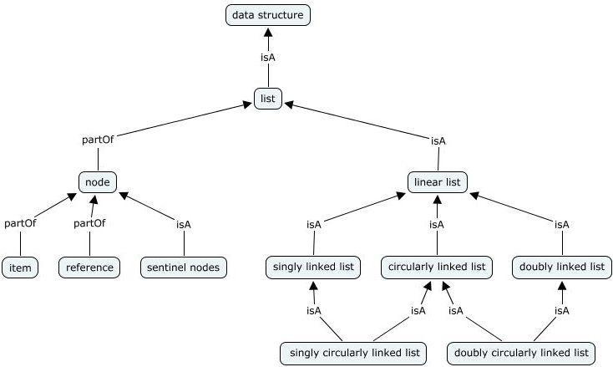
Data structure, Way in which data are stored for efficient search and retrieval. The simplest data structure is the one-dimensional (linear) array, in which stored elements are numbered with consecutive integers and contents are accessed by these numbers. Data items stored no consecutively in memory may be linked by pointers (memory addresses stored with items to indicate where the “next” item or items in the structure are located). Many algorithms have been developed for sorting data efficiently; these apply to structures residing in main memory and also to structures that constitute information systems and databases. Bits, Bytes, Characters, Fields, Records, Files, and Databases are examples

Activity | Questions Description | Mark
7 | List different types of file organization and structure. | 7

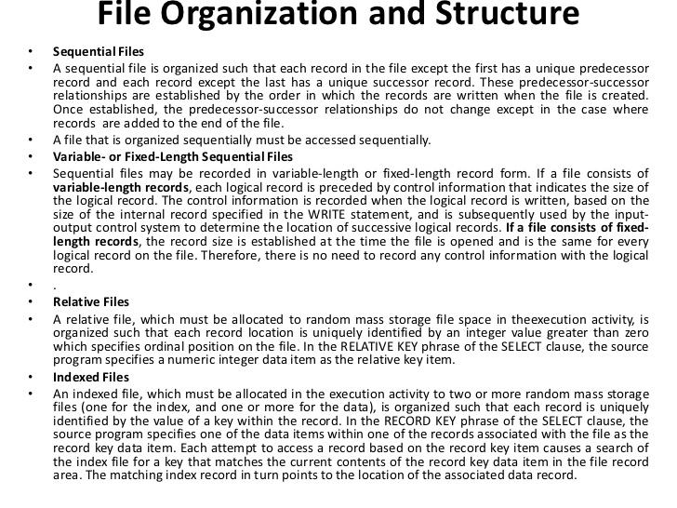

Activity | Questions Description | Mark
8 | Describe types of computer databases and identify examples | 12
Types of DBMS: Hierarchical Databases
There are four structural types of database management systems: hierarchical, network, relational, and object-oriented.
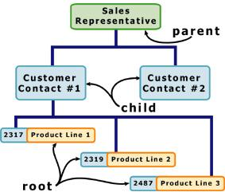
Hierarchical Databases (DBMS), commonly used on mainframe computers, have been around for a long time. It is one of the oldest methods of organizing and storing data, and it is still used by some organizations for making travel reservations. A hierarchical database is organized in pyramid fashion, like the branches of a tree extending downwards. Related fields or records are grouped together so that there are higher-level records and lower-level records, just like the parents in a family tree sit above the subordinated children. Based on this analogy, the parent record at the top of the pyramid is called the root record. A child record always has only one parent record to which it is linked, just like in a normal family tree. In contrast, a parent record may have more than one child record linked to it. Hierarchical databases work by moving from the top down. A record search is conducted by starting at the top of the pyramid and working down through the tree from parent to child until the appropriate child record is found. Furthermore, each child can also be a parent with children underneath it.
The advantage of hierarchical databases is that they can be accessed and updated rapidly because the tree-like structure and the relationships between records are defined in advance. However, this feature is a two-edged sword. The disadvantage of this type of database structure is that each child in the tree may have only one parent, and relationships or linkages between children are not permitted, even if they make sense from a logical standpoint. Hierarchical databases are so rigid in their design that adding a new field or record requires that the entire database be redefined.
Types of DBMS: Network Databases
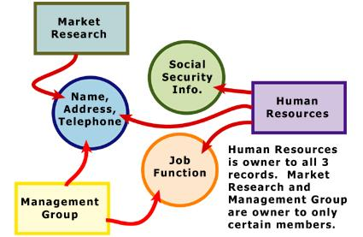
Network databases are similar to hierarchical databases by also having a hierarchical structure. There are a few key differences, however. Instead of looking like an upside-down tree, a network database looks more like a cobweb or interconnected network of records. In network databases, children are called membersand parents are called owners. The most important difference is that each child or member can have more than one parent (or owner). Like hierarchical databases, network databases are principally used on mainframe computers. Since more connections can be made between different types of data, network databases are considered more flexible. However, two limitations must be considered when using this kind of database. Similar to hierarchical databases, network databases must be defined in advance. There is also a limit to the number of connections that can be made between records.
Types of DBMS: Relational Databases
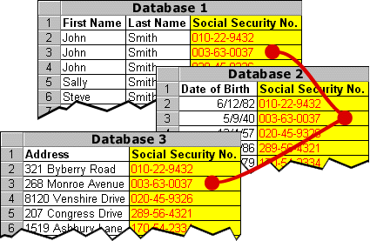
In relational databases, the relationship between data files is relational, not hierarchical. Hierarchical and network databases require the user to pass down through a hierarchy in order to access needed data. Relational databases connect data in different files by using common data elements or a key field. Data in relational databases is stored in different tables, each having a key field that uniquely identifies each row. Relational databases are more flexible than either the hierarchical or network database structures. In relational databases, tables or files filled with data are called relations, tuples designates a row or record, and columns are referred to as attributes or fields. Relational databases work on the principle that each table has a key field that uniquely identifies each row, and that these key fields can be used to connect one table of data to another. Thus, one table might have a row consisting of a customer account number as the key field along with address and telephone number. The customer account number in this table could be linked to another table of data that also includes customer account number (a key field), but in this case, contains information about product returns, including an item number (another key field). This key field can be linked to another table that contains item numbers and other product information such as production location, color, quality control person, and other data. Therefore, using this database, customer information can be linked to specific product information.
The relational database has become quite popular for two major reasons. First, relational databases can be used with little or no training. Second, database entries can be modified without redefining the entire structure. The downside of using a relational database is that searching for data can take more time than if other methods are used.
Types of DBMS: Object-oriented Databases (OODBMS)
Able to handle many new data types, including graphics, photographs, audio, and video, object-oriented databases represent a significant advance over their other database cousins. Hierarchical and network databases are all designed to handle structured data; that is, data that fits nicely into fields, rows, and columns. They are useful for handling small snippets of information such as names, addresses, zip codes, product numbers, and any kind of statistic or number you can think of. On the other hand, an object-oriented database can be used to store data from a variety of media sources, such as photographs and text, and produce work, as output, in a multimedia format. Object-oriented databases use small, reusable chunks of software called objects. The objects themselves are stored in the object-oriented database. Each object consists of two elements: 1) a piece of data (e.g., sound, video, text, or graphics), and 2) the instructions, or software programs called methods, for what to do with the data. Part two of this definition requires a little more explanation. The instructions contained within the object are used to do something with the data in the object. For example, test scores would be within the object as would the instructions for calculating average test score. Object-oriented databases have two disadvantages. First, they are more costly to develop. Second, most organizations are reluctant to abandon or convert from those databases that they have already invested money in developing and implementing. However, the benefits to object-oriented databases are compelling. The ability to mix and match reusable objects provides incredible multimedia capability. Healthcare organizations, for example, can store, track, and recall CAT scans, X-rays, electrocardiograms and many other forms of crucial data.

Now that you have completed this lesson, you should be able to:
- Compare and contrast the structure of different database management systems.
- Define hierarchical databases.
- Define network databases.
- Define relational databases.
- Define object-oriented databases.

